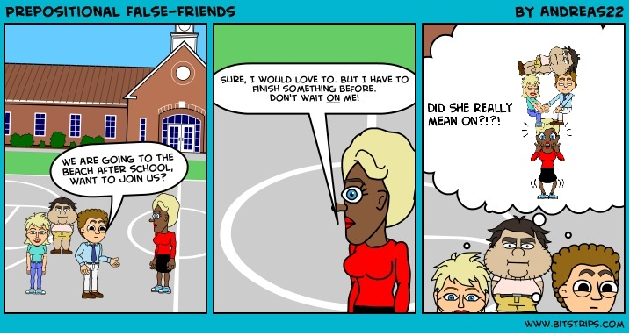
Please fill the gaps with one of the following prepositions:
of / on / since / for / at / in / after / about / to / by / up / with / down / through / above / behind / between / below
You may use the prepositions more than once. Note that in most cases there is only one correct answer.
1. I'm tired ____ waiting for you.
2. He hasn't smoked ____ ages.
3. Nina is good _____ running.
4. I'm looking _____ my keys. Has anyone found them?
5. They dream _____ moving to South Africa.
6. This song was written _____ Madonna.
7. You can look the word _____ in a dictionary.
8. I can't come to the party. Don't wait _____ me.
9. She had problems _____ reading the instructions.
10. The police car chased the robbers _____ the streets.
11. I have a question ______ the solar-system.
12. Could someone give an example ______ a bird?
13. Please look ______ my dog, while I am ______ vacation.
14. The Butter is ______ the fridge ______ the cheese.
15. The difference ______ elephants and unicorns is obvious.

